Name:

### Score: out of

# Eastern Goldfields College 2016

# Year 11 Mathematics Methods

# Test 4

# Indices, Exponential Functions, Trig

**33**

**Non Calculator Section (No calculator or notes, formula sheet provided)**

**Time: 30 minutes Marks: 33 marks**

1. [1,1 = 2 marks]

When intercepted by the spacecraft Horizon recently, Pluto was about 4 864 100 000 km from Earth.

a) Express this distance in scientific notation. ……………………………….

b) Write this distance in scientific notation

correct to 2 significant figures. ………………………………..

2. [3 marks]

|  |  |  |  |  |
| --- | --- | --- | --- | --- |
| x | 0 | 1 | 2 | 3 |
| y | 20 | 12 | 7.2 | 4.32 |

Determine the rule connecting x and y.

3. [4 marks]

Find the value of these expressions, writing your answer as a fraction where appropriate.

a) 2-3 b)  2-2

c)  d) 

4. [1 mark]

Estimate a solution to the equation 2x = 17, giving your estimate to one decimal place.

5. [2,4,1 = 7 marks]

Simplify the following leaving your answers as positive indices.

Show all working and steps.

1. a3b3 x a-2b-7 b) 
2. 

6 [2,2,2 = 6 marks]

Solve for x in each case showing working clearly.

1. 4x-3 =  b) 

c) 

7. [1,2,1 = 4 marks]

1. The number of feral cats in a National park was initially 3500 but decreasing at an annual

rate of 7.5%. Write a rule describing the number of cats after t years.

C = ……………………………….

The number of bacteria in a culture after t minutes is described by the rule B = 50(2.1)t+1.

1. Describe the percentage change in the number of bacteria each minute.
2. Find how many bacteria were present initially.

8. [1,2 = 3 marks]

The curve y = 2x is transformed into y = 2x + 4.

1. State the transformation that has occurred.
2. Find the rule below for Graph A if it represents a transformation of y = 2x. (dotted)

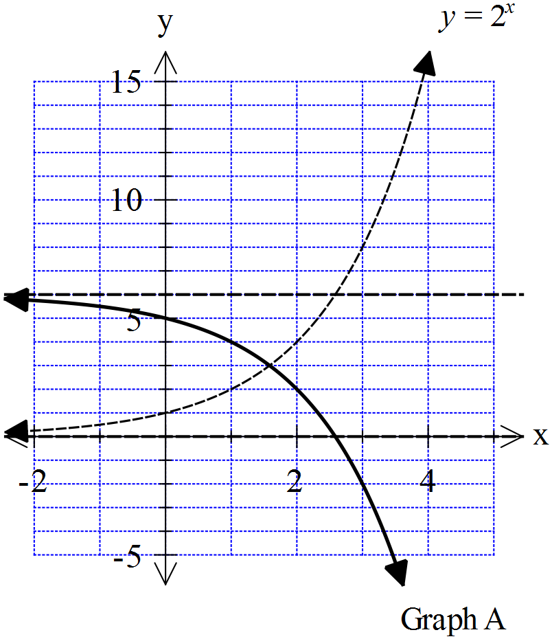

_____________________________________________________________________________________

9. [3 marks]

Solve $cosxcos10-sinxsin10=0.5$ for 

# Eastern Goldfields College 2016

# Year 11 Mathematics Methods

# Test 4

# Indices, Exponential Functions, Trig

Name:

### Score: out of

**30**

**Calculator Section (Calculators and 1 page (A4) of notes permitted, formula sheet provided)**

**Time: 30 minutes Marks: 30 marks**

10. [2,2 = 4 marks]

The changing population of Saudi Arabia is shown below.

|  |  |  |  |
| --- | --- | --- | --- |
| Year | 2000 | 2010 | 2015 |
| Population  (in millions) | 20.3 | 26.8 | 30.7 |

1. Find the yearly percentage growth in population. Show working.
2. Find the population in 2040, to the nearest 0.1 of a million.

Show all working to justify your answer.

11. [1,2,3 = 6 marks]

The amount of grams of a dangerous radioactive substance remaining after a dangerous accidental spill in a laboratory, at time t minutes, is given by the rule

A = 350(0.969)t.

1. How much radioactive substance was spilled initially?
2. How many grams remain after 1 hour?

Show how you did this question.

1. For the laboratory to be safe there must be less than 1 gram of the substance left.

Determine the time to the nearest minute, when it is safe to go back into the laboratory.

Show working clearly.

12. [2,1,1,2,2,2 = 10 marks]

The population of blue wrens in a particular area of the South West has been studied over 10 years. The results are represented on the graph given below.





The population is modelled by the exponential function  and a point on the graph is indicated.

a) Find the value of *b,* rounded to three decimal places. Indicate clearly how you found this.

b) State the annual percentage change in the population of wrens.

c) Find how many wrens were there after 13 years.

At the same time the number of numbats in the area has also been measured and found to be growing exponentially. After two years there were 96 numbats and after 6 years there were 138 numbats counted.

1. Mark these points on the axes above and sketch a curve showing how Numbats will increase.
2. Find a general rule for the number of Numbats at any time t.
3. Determine to the nearest 0.1 of a year, when the population of Numbats will equal the population of Wrens.

13. [2,2 = 4 marks]

The graph of an exponential function has a horizontal asymptote of y = 3, a y-intercept of (0,1) and goes through the point (2,-15).

1. Sketch the function below, indicating all key information..

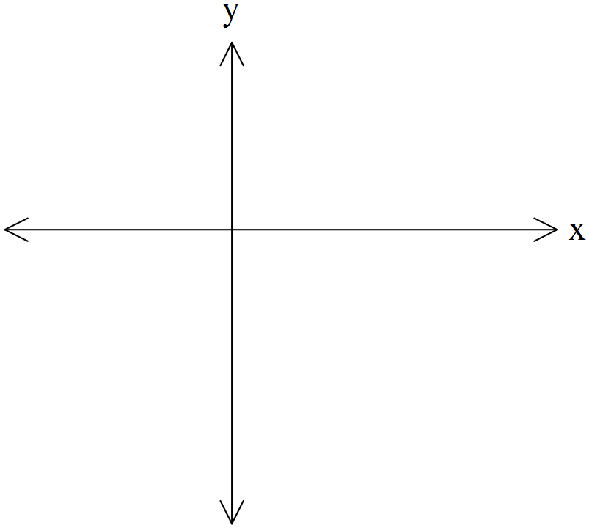

1. Find a possible rule for the function in the form y = kax + b.

14. [3, 3= 6 marks]

(a)  and  are both obtuse angles such that  and . Determine an exact value for .

(b) State the exact values of  and , and hence show that the exact value of  is . (3 marks)

THE END